ASSIGNMENT 1

Write the HTML for the following screen

<!DOCTYPE html>

<html>

<head>

<title>Page Title</title>

</head>

<body style="background-color:Yellow;">

<h1 style= "background-color:red;">This is a Heading</h1>

<p style= "background-color:green;">This is a paragraph.</p>

</body>

</html>

ANS:

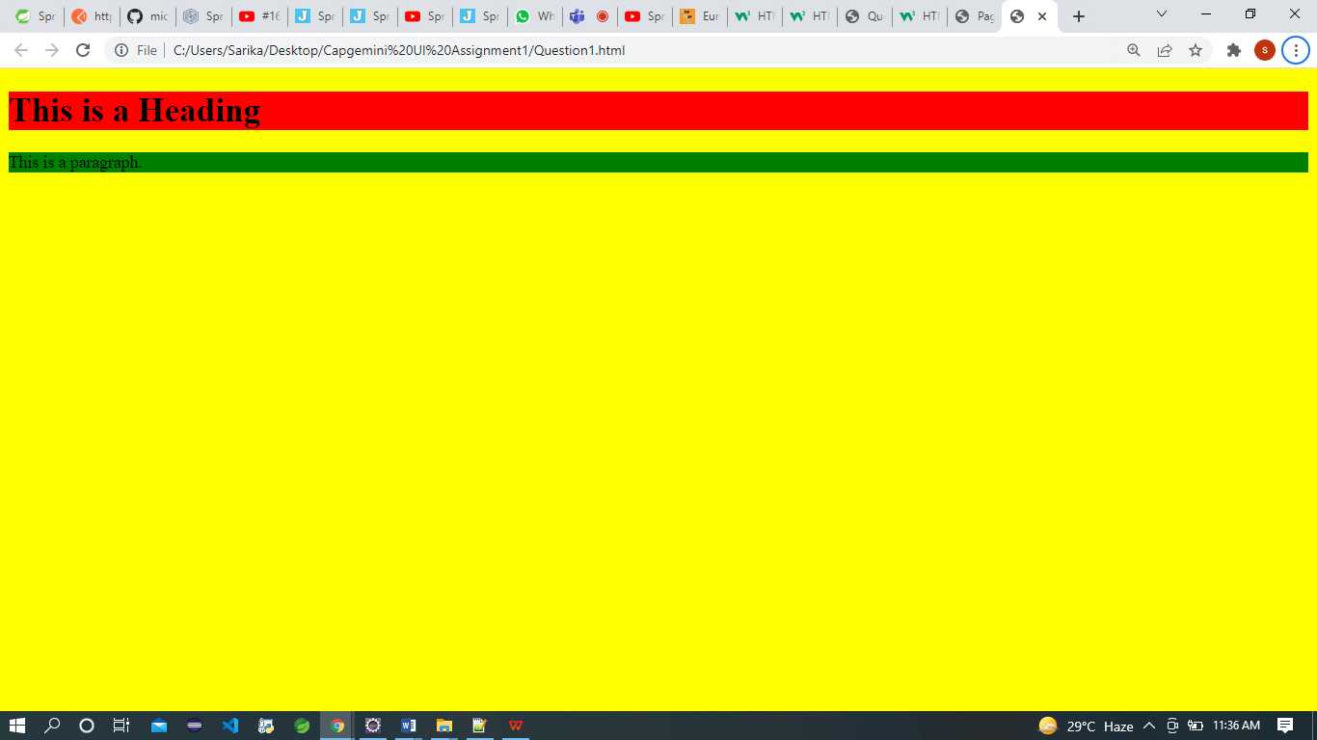

2.

<!DOCTYPE html>

<html>

<head>

</head>

<body>

<a href="C:\Users\Sarika\Desktop\image1.jpg" border="100" >Create a link of an image

</a>

</pre>

<body>

The following image works as a link:<br>

<a href="https://www.qries.com/">

<img alt="Qries" src="https://www.qries.com/images/banner_logo.png"

width=150" height="70">

</a>

</body>

</html>

3.

<!DOCTYPE html>

<html>

<head>

<style>

th, td {

border:1px solid black;

}

</style>

</head>

<body>

<table>

<h4>One Row and three column </h4>

<tr>

<td>100</td>

</table>

<pre>

<table>

<h4>One Row and three column </h4>

<tr>

<td>100</td>

<td>200</td>

<td>300</td>

</tr>

</table>

<table>

<h4>This table has border </h4>

<tr>

<td>100</td>

<td>200</td>

<td>300</td>

</tr>

<tr>

<td>400</td>

<td>500</td>

<td>600</td>

</tr>

</body>

</html>

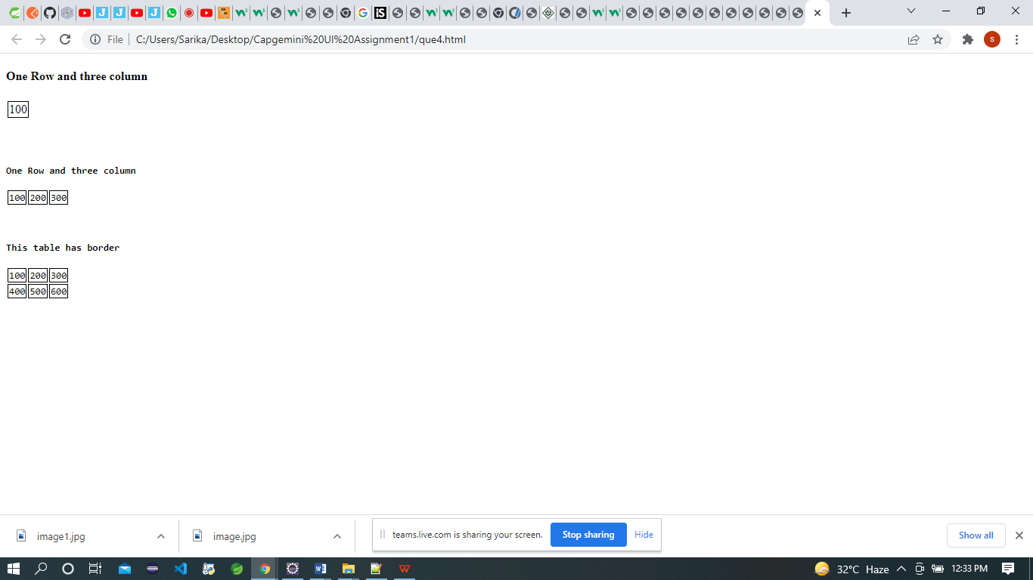

4.

<!DOCTYPE html>

<html>

<head>

</head>

<body>

<table>

<h4>This border has no border </h4>

<tr>

<td>100</td>

<td>200</td>

<td>300</td>

</tr>

<tr>

<td>400</td>

<td>500</td>

<td>600</td>

</tr>

</body>

</html>

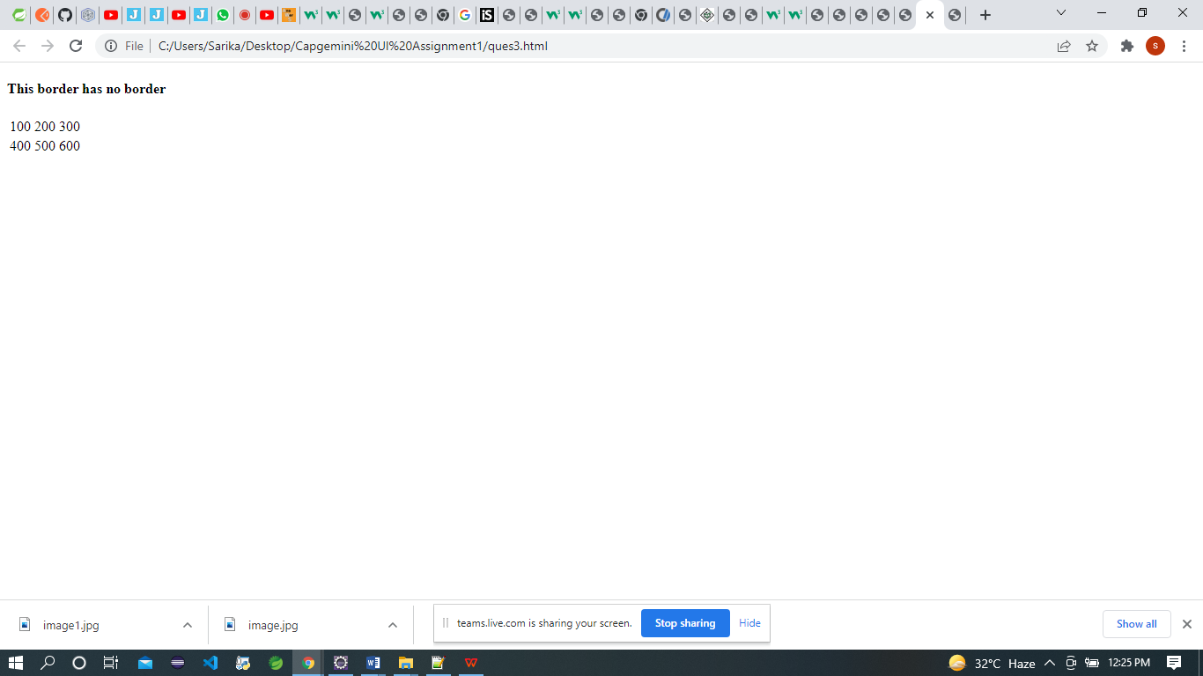

5.

<!DOCTYPE html>

<html>

<head>

<title>Page Title</title>

</head>

<h4>Numbered list </h4>

<ol>

<li>Apple</li>

<li>Bananas</li>

<li>Lemons</li>

<li>Oranges</li>

</ol>

<h4>Letters List </h4>

<ol type="A">

<li>Apple</li>

<li>Bananas</li>

<li>Lemons</li>

<li>Oranges</li>

</ol>

<h4>LowerLetter</h4>

<ol type="a">

<li>Apple</li>

<li>Bananas</li>

<li>Lemons</li>

<li>Oranges</li>

</ol>

<h4>Roman Letter </h4>

<ol type="I">

<li>Apple</li>

<li>Bananas</li>

<li>Lemons</li>

<li>Oranges</li>

</ol>

<h4>Roman Letter </h4>

<ol type="i">

<li>Apple</li>

<li>Bananas</li>

<li>Lemons</li>

<li>Oranges</li>

</ol>

</body>

</html>

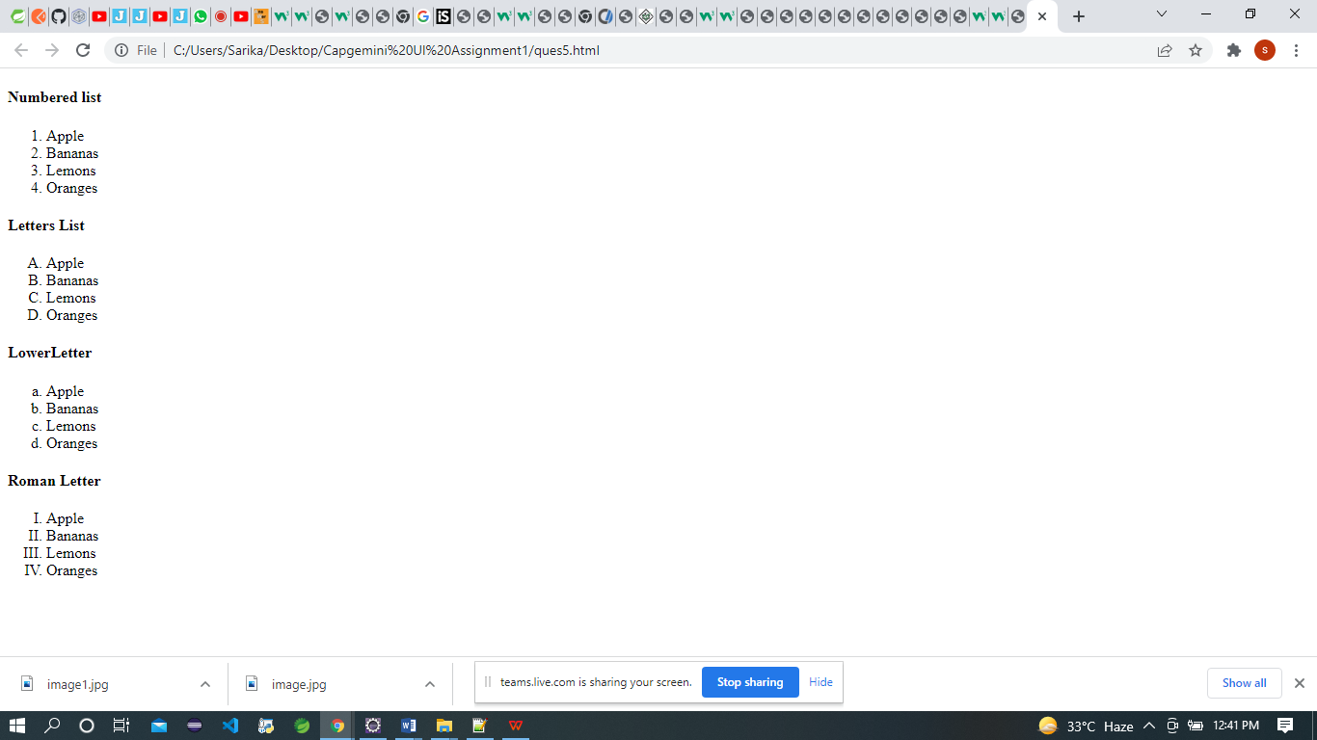

6.

<!DOCTYPE html>

<html>

<head>

<title>Page Title</title>

</head>

<body>

<form>

<label>Username : </label>

<input type="text" placeholder="Enter Username" name="username" required>

<br>

<br>

<label>Password : </label>

<input type="password" placeholder="Enter Password" name="password" required>

</form>

</body>

</html>

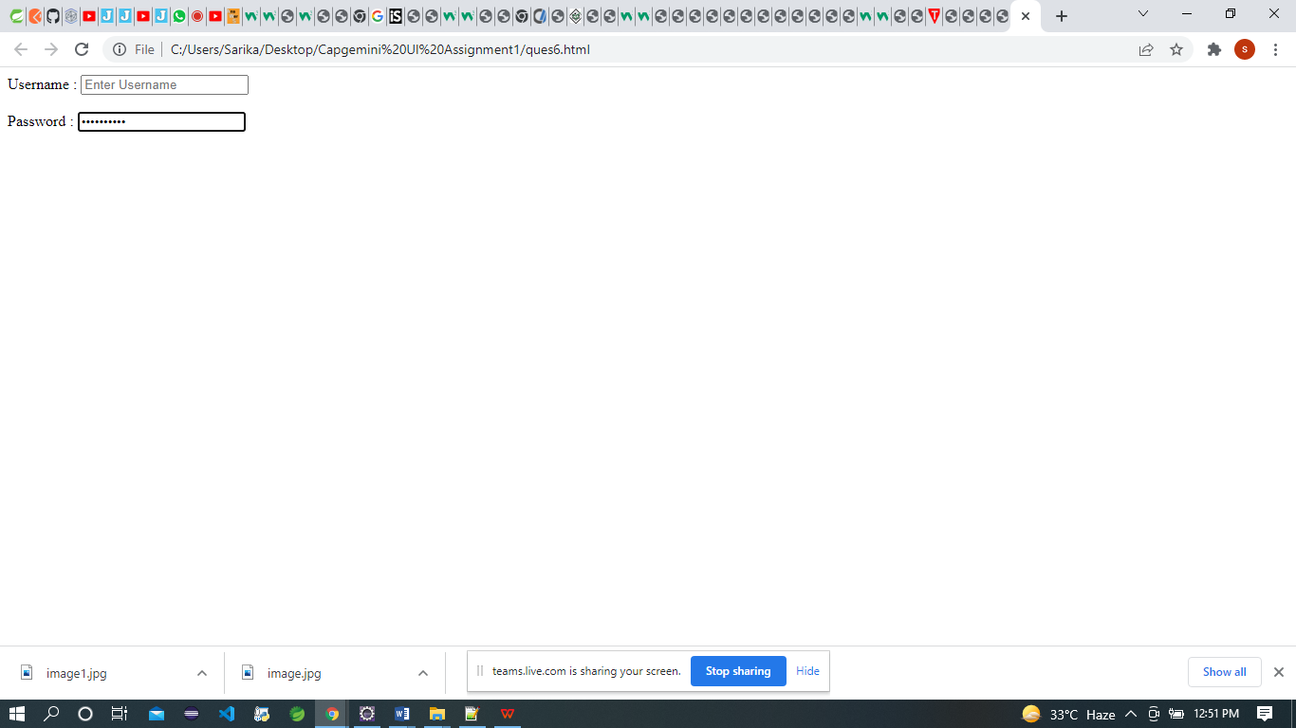

7.

<!DOCTYPE html>

<html>

<head>

<title>Page Title</title>

</head>

<body>

<input type="checkbox" /> I have a Bike

<br>

<input type="checkbox" /> I have a car

<br>

<button type="submit">Submit</button>

</body>

</html>

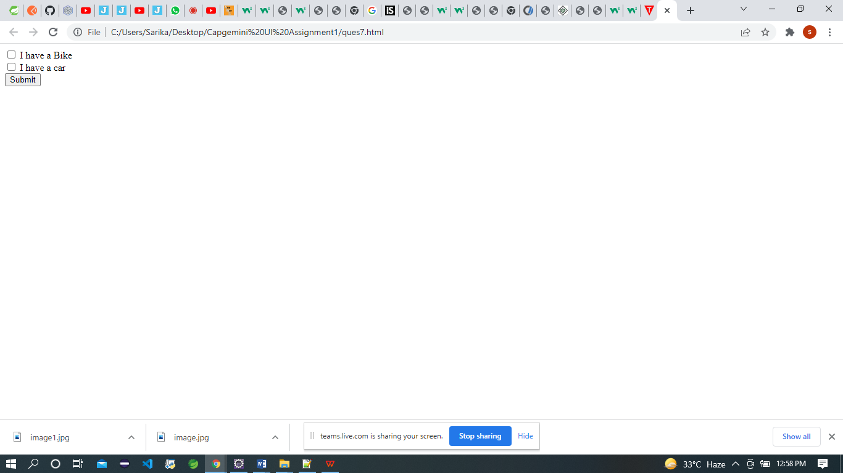

8.

9.

<!DOCTYPE html>

<html>

<head>

<title>assignment 8</title>

</head>

<body>

<div style = "width:100%">

<div style = "background-color:green; height:100px; width:50%; float:left;">

<h1>Top Left</h1>

</div>

<div style = "background-color:green; height:100px; width:50%; float:right;">

<h1>Top Right</h1>

</div>

<div style = "background-color:grey; height:100px; width:50%; float:left;">

<h1>Left bottom</h1>

</div>

<div style = "background-color:darkgrey; height:100px; width:50%; float:right;">

<h1>Right bot</h1>

</div>

</div>

</body>

</html>

